Trends in six countries since 2000: GDP and Life Expectancy

I’ve had a chance to work with some data related to six nations, scattered around the globe:

1. Chile
2. China
3. Mexico
4. Germany
5. United States of America
6. Zimbabwe

The data was provided by the World Health Organization. WHO is generally recognized as a reliable source of data. A concern to keep in mind as we look at some visualizations based on the data is not related to the provider of it (almost certainly trustworthy) but rather how to interpret these two indices.

## Gross Domestic Product (GDP)

GDP is regarded as a dependable indicator of the health of a nation’s economy. So one would think that, as is true with most scores, the higher it is, the better.

Alisa Roth of National Public Radio’s weekday show, [Marketplace](https://www.marketplace.org/2011/01/28/world/interpreting-gdp) points out that GDP can be too extreme in one direction or another. It’s also relative to its own progress, as well as to other GDPs in the global economy. Emerging economies (like China, represented in this data set), for example, can experience too much GDP growth. GDP should also be measured in context along with other indicators. The USA and Germany are mature economies in this data set. It is hard to make complete sense of the trends in these countries without knowing about the housing market. Given the history of the USA’s housing market over this 15 year period (with a large economic crash and housing market bubble about 8 years in), it would be important to get that data for a comprehensive evaluation of the data.

**Life Expectancy**

Taken at face value, life expectancy at birth is reasonable to use as an indicator of well-being in a nation. It does have some limitations. As is true with GDP it should not be interpreted in a vacuum. Although a long (USA), or increasing (Zimbabwe) lifespan is a sign of positive trends in health and access to economic resources, a more granular view of the lifespan is more informative. In the USA, which has one of the longer lifespans in this data set, it is hard to know if those extended years are spent optimally. According to the [CDC](https://www.cdc.gov/chronicdisease/overview/index.htm), while citizens of the United States are among the most long-lived on the planet, they spend many of their later years experiencing chronic diseases such as CVD and diabetes. The extended lifespan may reflect access to pharmaceutic treatments that control but do not actually cure the condition. In Zimbabwe, lifespans have gotten dramatically longer relative to the other countries in the sample, but with respect to their starting point (relative to other countries) there is surely more progress to be made.

## Life Expectancy Comparison

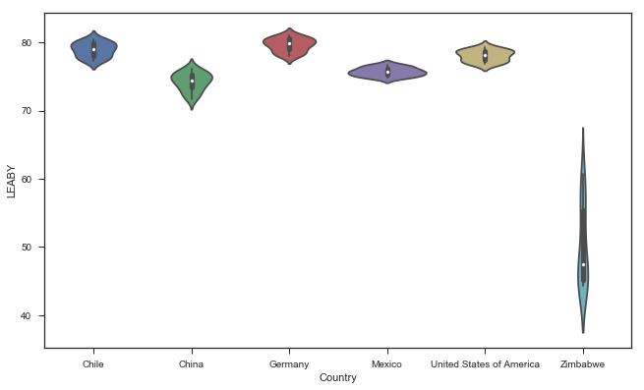

Figure : Life Expectancy in Six Nations 2000-2015

Zimbabwe had the greatest increase in life expectancy over the first decade and a half of this century. It still, however, lags behind China, which had substantial economic instability in the mid-20th Century, and Chile, which has had periods of political turmoil in the second half of the 20th Century. In fact, it has not yet attained an expectancy equal to their poorest scores on this index.

## Life Expectancy by GDP of Country

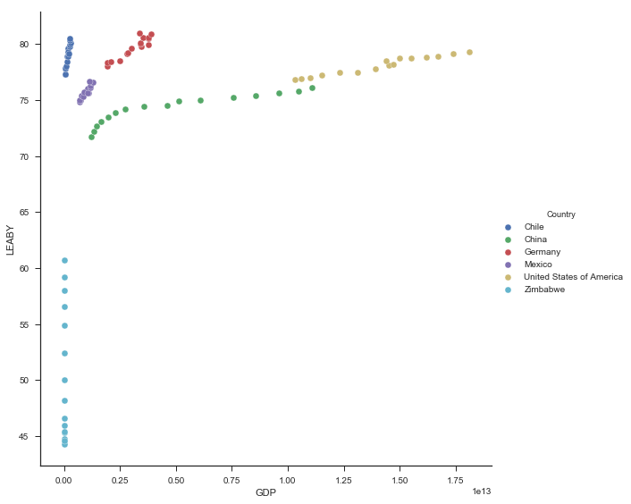

Figure : Life Expectancy by GDP of Country

As a substantiation of my suspicion that Life Expectancy alone is not a sufficient index of well-being for some global economies, the trends shown above suggest that Zimbabwe’s increasing life expectancy is almost certainly a good sign that resources and health services may be improving there, but is not necessarily indicative of improvements in the nation’s economy.

## GDP by Country

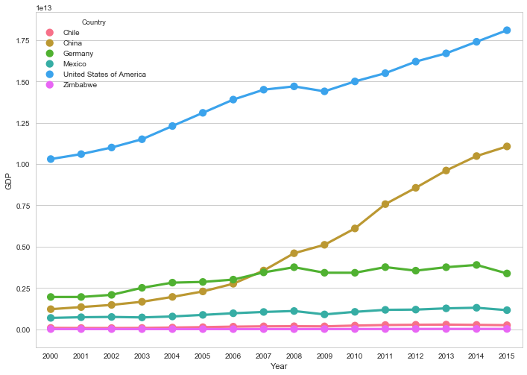

Figure : Gross Domestic Product by Country 2000-2015

The line charts above and below show the interesting contrast between the USA, China and Zimbabwe.

GDP is rising in China (dramatically) and the USA (moderately) but is flat (not increasing or decreasing noticeably) in Zimbabwe. Life Expectancy is rising dramatically in Zimbabwe, while all the developed nations in this sample are manifesting slow, steady increases in this area.

## Life Expectancy by Country

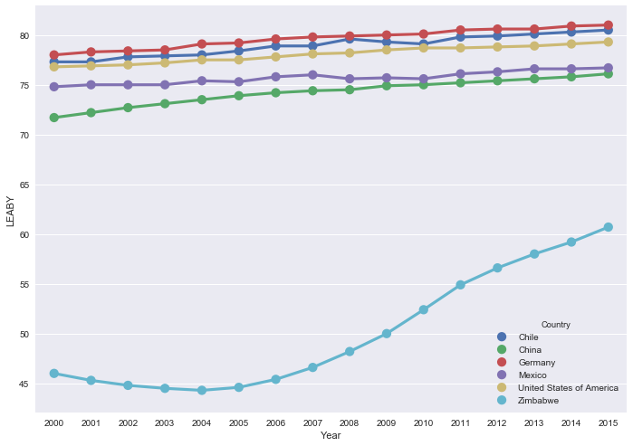

Figure : Life Expectancy by Country 2000-2015

## Concluding Thoughts

The positive trends visualized above give us reason to be optimistic. It is clear though that organizations that promote economic development need to continue to pay attention to Zimbabwe and (most likely) its neighbors. A larger sample of countries and a longer timeframe would likely increase our understanding of what is occurring and where further attention and provision of resources would most effectively be applied.

Nancy J. Melucci

Huntington Beach CA

15 July 2018